**Source Code**

//******************header files*******************

#include<fstream.h>

#include<conio.h>

#include<string.h>

#include<ctype.h>

#include<stdio.h>

#include<process.h>

//******File Stream Objects******

fstream fout; // ofstream writing

fstream fin; // ifstream reading

//==============================================

//TRAVEL BY AIRWAYS

class travel

{

int mem; //input the members

char name[20]; //take input name

char id[30]; //take email id

char tra; //take mode of travel

unsigned int price; //price of travelling

char dest[30]; //travel destination

public:

travel()

{ mem=0;

tra='a';

price=0;

}

char ret_tra() //return mode of travel

{ return tra; }

char* ret_name() //return name

{ return name; }

char* ret_id() //return email id

{ return id; }

void input();

void travelling(char,int);

void output();

}t;

//Airway class object = t

void travel::travelling(char choice,int mem)

{

int xx;

if(choice=='n'||choice=='N')

{ cout<<"\n 1.Flight-> Delhi to Jaipur";

cout<<"\n 2.Flight-> Delhi to Mumbai";

cout<<"\n 3.Flight-> Delhi to Chennai";

cout<<"\n 4.Flight-> Delhi to Kolkata";

cout<<"\n Enter your choice : ";

cin>>xx;

cout<<"\n Booking confirmed";

cout<<"\n Price generted\n";

if(xx==1)

{ price=(mem*2500);

strcpy(dest,"Delhi to Jaipur");

}

if(xx==2)

{ price=(mem*3500);

strcpy(dest,"Delhi to Mumbai");

}

if(xx==3)

{ price=(mem*4000);

strcpy(dest,"Delhi to Chennai");

}

if(xx==4)

{ price=(mem*3200);

strcpy(dest,"Delhi to Kolkata");

}

}

if(choice=='i'||choice=='I')

{ cout<<"\n 1.Flight-> Delhi to USA";

cout<<"\n 2.Flight-> Delhi to Australia";

cout<<"\n 3.Flight-> Delhi to France";

cout<<"\n 4.Flight-> Delhi to Switzerland";

cout<<"\n Enter your choice : ";

cin>>xx;

cout<<"\n Booking confirmed";

cout<<"\n Price generted\n";

if(xx==1)

{ price=(mem*7000);

strcpy(dest,"Delhi to USA");

}

if(xx==2)

{ price=(mem*4500);

strcpy(dest,"Delhi to Australia");

}

if(xx==3)

{ price=(mem*5000);

strcpy(dest,"Delhi to France");

}

if(xx==4)

{ price=(mem*8000);

strcpy(dest,"Delhi to Switzerland");

}

}

}

void travel::input()

{

cout<<"\n Enter your name : ";

gets(name);

cout<<"\n Enter e-mail id : ";

gets(id);

cout<<"\n Enter the no. of passengers you are travel with : ";

cin>>mem;

if(mem>=1 && mem<=10)

{ cout<<"\n Where you want to travel (National = N & Internationl = I) : ";

cin>>tra;

}

travelling(tra,mem);

}

void travel::output()

{ cout<<"\n NAME : "<<name;

cout<<"\n E-MAIL : "<<id;

cout<<"\n PASSENGERS : "<<mem;

cout<<"\n TRAVELLING NATIONAL/INTERNATIONAL : "<<tra;

cout<<"\n DESTINATION : "<<dest;

cout<<"\n TRAVELLING PRICE : "<<price;

}

void entry() //take the entry

{ char ch='y';

fout.open("fly.dat",ios::app|ios::binary);

while(ch=='y'||ch=='Y')

{ system("cls");

t.input();

fout.write((char*)&t,sizeof(t));

cout<<"\n More Record (Y/N) : ";

cin>>ch;

}

fout.close();

}

void display() //display the entry

{ fin.open("fly.dat",ios::in|ios::binary);

fin.seekg(0);

fin.read((char*)&t,sizeof(t));

while(!fin.eof())

{ t.output();

cout<<endl;

fin.read((char*)&t,sizeof(t));

}

fin.close();

}

void search() //search the entry

{ fin.open("fly.dat",ios::in|ios::app|ios::binary);

char n[20];

cout<<"\nSearch Your Booking by name : ";

gets(n);

while(fin.read((char*)&t,sizeof(t)))

{ if(strcmpi(n,t.ret_name())==0)

{ t.output();

fin.read((char*)&t,sizeof(t));

}

}

fin.close();

}

void delete_booking(char* id) //delete the entry

{ fin.open("fly.dat",ios::in|ios::binary);

fout.open("second.dat",ios::out|ios::binary);

char found='n';

while(fin.read((char*)&t,sizeof(t)))

{ if(strcmpi(id,t.ret_id())!=0)

{ fout.write((char*)&t,sizeof(travel)); }

else

{ found='y'; }

}

if(found=='n')

cout<<"\n record not found";

fin.close();

fout.close();

cout<<"\n Account deleted\n";

remove("fly.dat");

rename("second.dat","fly.dat");

}

void flight()

{ int x; char ans; char id1[30];

do{ clrscr();

cout<<"\n....WELCOME TO AIRWAY SERVICES....";

cout<<"\n 1.Booking for flight";

cout<<"\n 2.Display bookings";

cout<<"\n 3.Search your booking";

cout<<"\n 4.Delete booking";

cout<<"\n enter your choice : ";

cin>>x;

switch(x)

{ case 1: entry();

break;

case 2: display();

break;

case 3: search();

break;

case 4:

cout<<"\n Enter the id to be deleted : ";

gets(id1);

delete_booking(id1);

break;

default:

cout<<"\n Try Again\n";

}

cout<<"\n GO BACK TO AIRWAY SERVICES : ";

cin>>ans;

}while(ans=='y'||ans=='Y');

}

//==============================================

//TRAVEL BY RAILWAYS

class rail

{

int mem; //take the input of members

char name[20]; //take input name

char id[30]; //take email id

unsigned int price; //take the travelling price

char dest[30]; //take the input of destination

public:

rail()

{ mem=0;

price=0;

}

char* ret_name()

{ return name; }

char* ret_id()

{ return id; }

void input();

void travelling(int);

void output();

}r;

//Railway class object = r

void rail::travelling(int mem)

{

int xx;

cout<<"\n 1.Train-> Delhi to Bhopal";

cout<<"\n 2.Train-> Delhi to Patna";

cout<<"\n 3.Train-> Delhi to Varanasi";

cout<<"\n 4.Train-> Delhi to Punjab";

cout<<"\n 5.Train-> Delhi to Lucknow";

cout<<"\n Enter your choice : ";

cin>>xx;

cout<<"\n Booking confirmed";

cout<<"\n Price generted\n";

if(xx==1)

{ price=(mem*1000);

strcpy(dest,"Delhi to Bhopal");

}

if(xx==2)

{ price=(mem*800);

strcpy(dest,"Delhi to Patna");

}

if(xx==3)

{ price=(mem*500);

strcpy(dest,"Delhi to Varanasi");

}

if(xx==4)

{ price=(mem*450);

strcpy(dest,"Delhi to Punjab");

}

if(xx==5)

{ price=(mem*600);

strcpy(dest,"Delhi to Lucknow");

}

}

void rail::input()

{

cout<<"\n Enter your name : ";

gets(name);

cout<<"\n Enter e-mail id : ";

gets(id);

cout<<"\n Enter the no. of passengers you are travel with : ";

cin>>mem;

if(mem>=1 && mem<=8)

{ travelling(mem);

}

}

void rail::output()

{ cout<<"\n NAME : "<<name;

cout<<"\n E-MAIL : "<<id;

cout<<"\n PASSENGERS : "<<mem;

cout<<"\n DESTINATION : "<<dest;

cout<<"\n TRAVELLING PRICE : "<<price;

}

void entry1() //take the entry

{

fout.open("rail.dat",ios::app|ios::binary);

while(1)

{ system("cls");

r.input();

fout.write((char*)&r,sizeof(r));

break;

}

fout.close();

}

void display1() //display the entry

{ fin.open("rail.dat",ios::in|ios::binary);

fin.seekg(0);

fin.read((char*)&r,sizeof(r));

while(!fin.eof())

{ r.output();

cout<<endl;

fin.read((char*)&r,sizeof(r));

}

fin.close();

}

void search1() //search the entry

{ fin.open("rail.dat",ios::in|ios::app|ios::binary);

char n[20];

cout<<"\nSearch Your Booking by name : ";

gets(n);

while(fin.read((char*)&r,sizeof(r)))

{ if(strcmpi(n,r.ret_name())==0)

{ r.output();

fin.read((char*)&r,sizeof(r));

}

}

fin.close();

}

void delete_booking1(char* id) //delete the entry

{ fin.open("rail.dat",ios::in|ios::binary);

fout.open("new.dat",ios::out|ios::binary);

char found='n';

while(fin.read((char*)&r,sizeof(r)))

{ if(strcmpi(id,r.ret_id())!=0)

{ fout.write((char*)&r,sizeof(rail)); }

else

{ found='y'; }

}

if(found=='n')

cout<<"\n record not found";

fin.close();

fout.close();

cout<<"\n Account deleted\n";

remove("rail.dat");

rename("new.dat","rail.dat");

}

void train()

{ int x; char ans; char id1[30];

do{ clrscr();

cout<<"\n....WELCOME TO RAILWAY SERVICES....";

cout<<"\n 1.Booking for train";

cout<<"\n 2.Display bookings";

cout<<"\n 3.Search your booking";

cout<<"\n 4.Delete booking";

cout<<"\n enter your choice : ";

cin>>x;

switch(x)

{ case 1: entry1();

break;

case 2: display1();

break;

case 3: search1();

break;

case 4:

cout<<"\n Enter the id to be deleted : ";

gets(id1);

delete_booking1(id1);

break;

}

cout<<"\n GO BACK TO RAILWAY SERVICES : ";

cin>>ans;

}while(ans=='y'||ans=='Y');

}

//=========================================================

//TAVEL BY TAXI

class taxi

{

int mem; //take the input of members

char name[20]; //take input name

char id[30]; //take email id

unsigned int price; //take the travelling price

char dest[30]; //take the input of destination

int base; //base fare = 50

int pkm; //price per kilometer = 8

int distance; //take the value of distance

public:

taxi()

{ mem=0;

price=0;

pkm=8;

base=50; //base fare of taxi

}

char* ret_name()

{ return name; }

char* ret_id()

{ return id; }

void input();

void travelling(char []);

void output();

}ti;

//Roadway class object = ti

void taxi::travelling(char dest[])

{ if(strcmpi(dest,"Market")==0)

{ distance=15;

}

if(strcmpi(dest,"Hospital")==0)

{ distance=20;

}

if(strcmpi(dest,"Police Station")==0)

{ distance=10;

}

if(strcmpi(dest,"School")==0)

{ distance=8;

}

if(strcmpi(dest,"Mall")==0)

{ distance=12;

}

price=base+(pkm*distance);

}

void taxi::input()

{

cout<<"\n Enter your name : ";

gets(name);

cout<<"\n Enter e-mail id : ";

gets(id);

cout<<"\n Enter the no. of passengers you are travel with : ";

cin>>mem;

if(mem>=1 && mem<=6)

{ cout<<"\n Enter the destination : ";

gets(dest);

travelling(dest);

}

else exit(1);

}

void taxi::output()

{ cout<<"\n NAME : "<<name;

cout<<"\n E-MAIL : "<<id;

cout<<"\n PASSENGERS : "<<mem;

cout<<"\n DESTINATION : "<<dest;

cout<<"\n DISTANCE : "<<distance;

cout<<"\n TRAVELLING PRICE : "<<price;

}

void entry2() //take the entry

{

fout.open("taxi.dat",ios::app|ios::binary);

while(1)

{ system("cls");

ti.input();

fout.write((char*)&ti,sizeof(ti));

break;

}

fout.close();

}

void display2() //display the entry

{ fin.open("taxi.dat",ios::in|ios::binary);

fin.seekg(0);

fin.read((char*)&ti,sizeof(ti));

while(!fin.eof())

{ ti.output();

cout<<endl;

fin.read((char*)&ti,sizeof(ti));

}

fin.close();

}

void search2() //search the entry

{ fin.open("taxi.dat",ios::in|ios::app|ios::binary);

char n[20];

cout<<"\nSearch Your Booking by name : ";

gets(n);

while(fin.read((char*)&ti,sizeof(ti)))

{ if(strcmpi(n,ti.ret_name())==0)

{ ti.output();

fin.read((char*)&ti,sizeof(ti));

}

}

fin.close();

}

void delete_booking2(char* id) //delete the entry

{ fin.open("taxi.dat",ios::in|ios::binary);

fout.open("data.dat",ios::out|ios::binary);

char found='n';

while(fin.read((char*)&ti,sizeof(ti)))

{ if(strcmpi(id,ti.ret_id())!=0)

{ fout.write((char*)&ti,sizeof(taxi)); }

else

{ found='y'; }

}

if(found=='n')

cout<<"\n record not found";

fin.close();

fout.close();

cout<<"\n Account deleted\n";

remove("taxi.dat");

rename("data.dat","taxi.dat");

}

void road()

{ int x; char ans; char id1[30];

do{ clrscr();

cout<<"\n....WELCOME TO ROADWAY SERVICES....";

cout<<"\n 1.Booking for taxi";

cout<<"\n 2.Display bookings";

cout<<"\n 3.Search your booking";

cout<<"\n 4.Delete booking";

cout<<"\n enter your choice : ";

cin>>x;

switch(x)

{ case 1: entry2();

cout<<"\n Booking confirmed";

cout<<"\n Price generted\n";

break;

case 2: display2();

break;

case 3: search2();

break;

case 4:

cout<<"\n Enter the id to be deleted : ";

gets(id1);

delete_booking2(id1);

break;

}

cout<<"\n GO BACK TO TAXI SERVICES : ";

cin>>ans;

}while(ans=='y'||ans=='Y');

}

void main()

{ clrscr();

int ch; char ans='y';

do{ clrscr();

cout<<"\n\t __ ___ ___ ";

cout<<"\n\t |\\/| |__| | |\\ | |\\/| |__ |\\ | | | ";

cout<<"\n\t | | | | _|_ | \\| | | |___ | \\| |___| "<<endl;

cout<<"\n 1.Airplane booking...";

cout<<"\n 2.Railway booking...";

cout<<"\n 3.Taxi booking...";

cout<<"\n Enter your choice : ";

cin>>ch;

switch(ch)

{ case 1:

flight();

break;

case 2:

train();

break;

case 3:

road();

break;

default:

cout<<"\n Don't waste our time\n";

}

cout<<"\n DO YOU WANT TO GOBACK TO MAIN MENU ('Y' OR 'y') : ";

cin>>ans;

}while(ans=='y'||ans=='Y');

getch();

}

**OUTPUT**

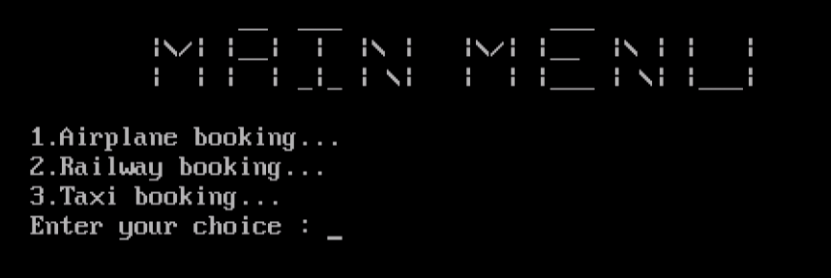

**//********Airplane Booking Services\*\*\*\*\*\*\*\***

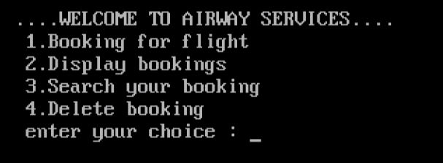

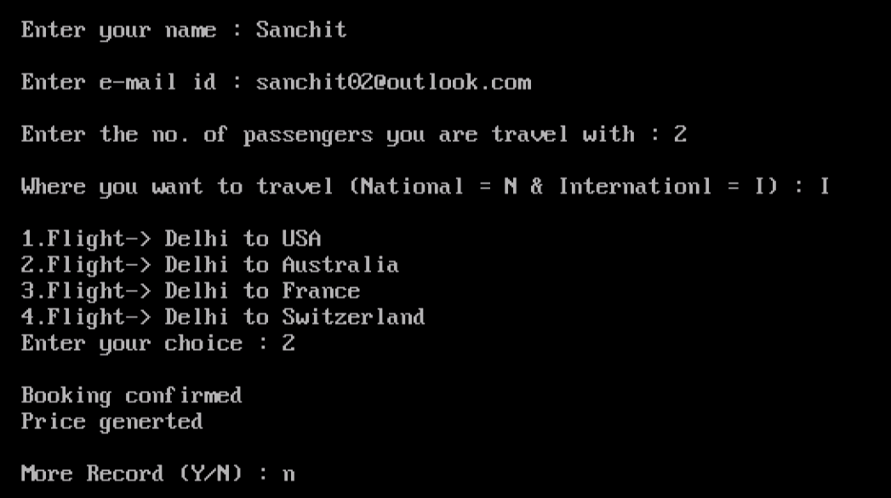

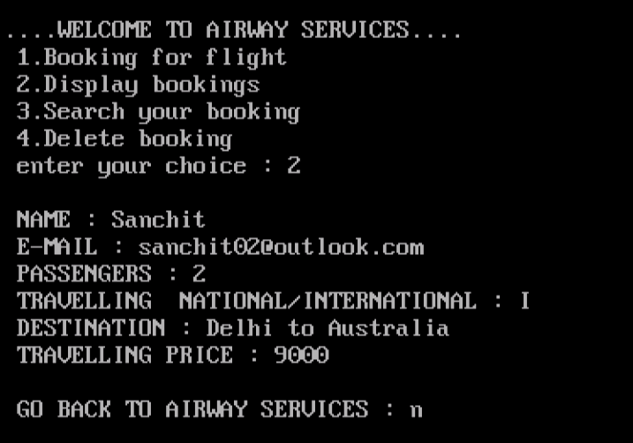

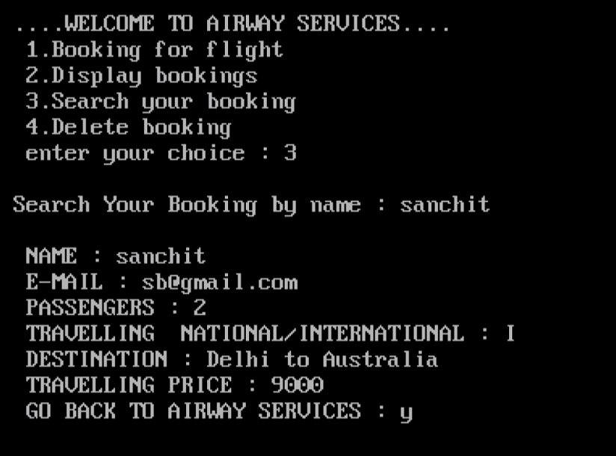

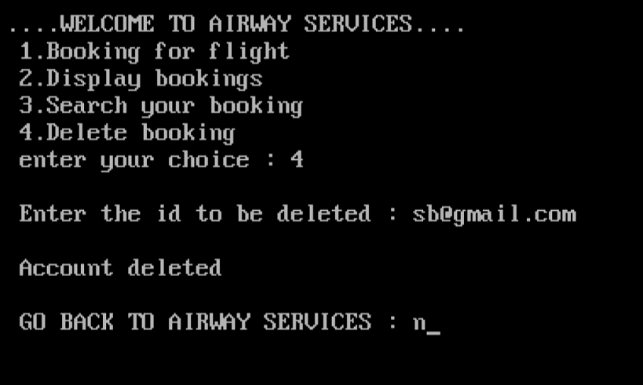

**//********Train Booking Services********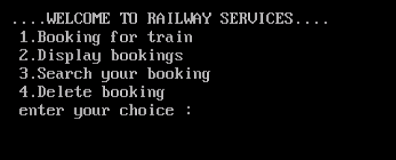**

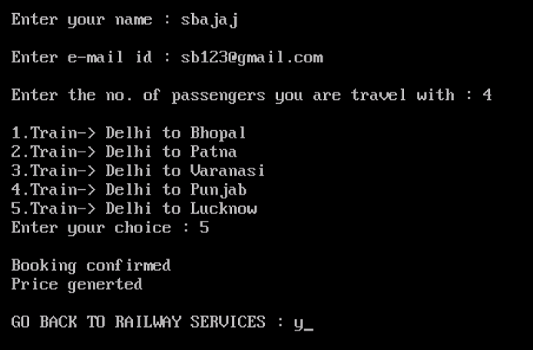

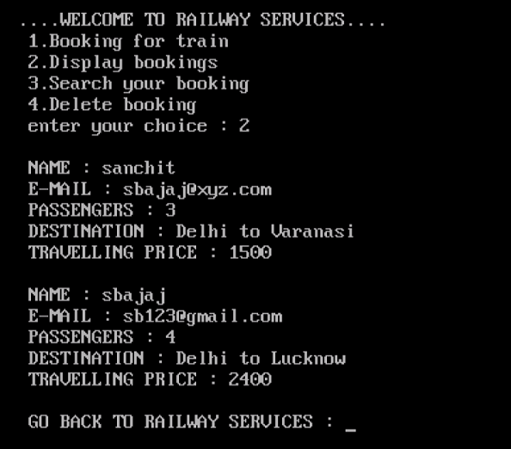

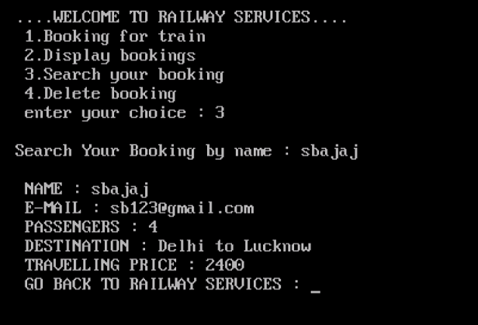

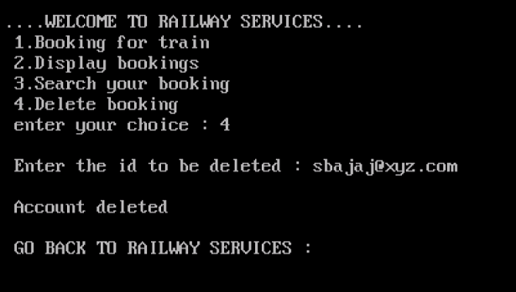

**//********Taxi Booking Services\*\*\*\*\*\*\*\***

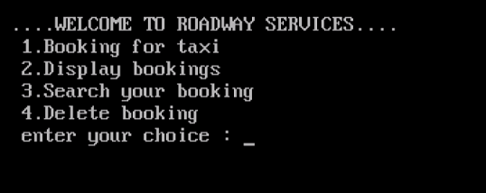

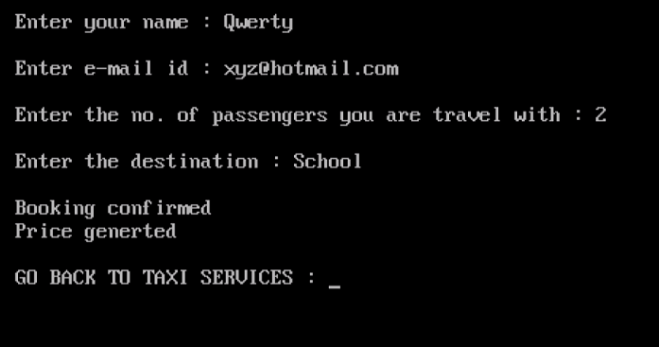

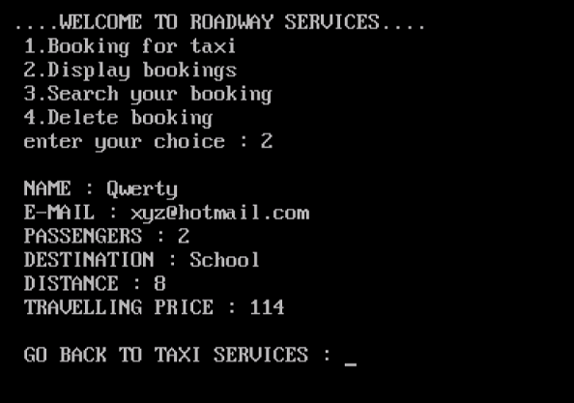

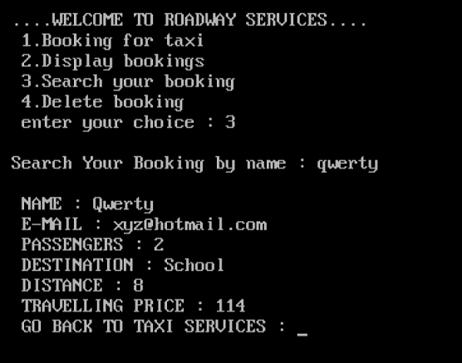

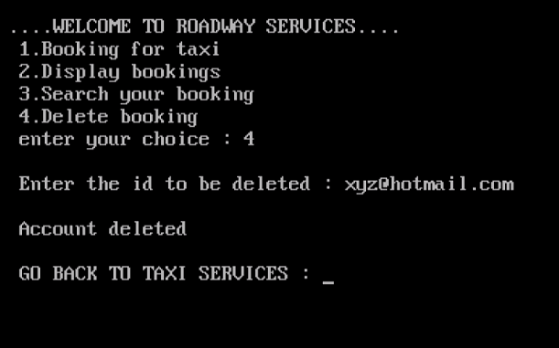

**//******BINARY FILE\*\*\*\*\*\***

